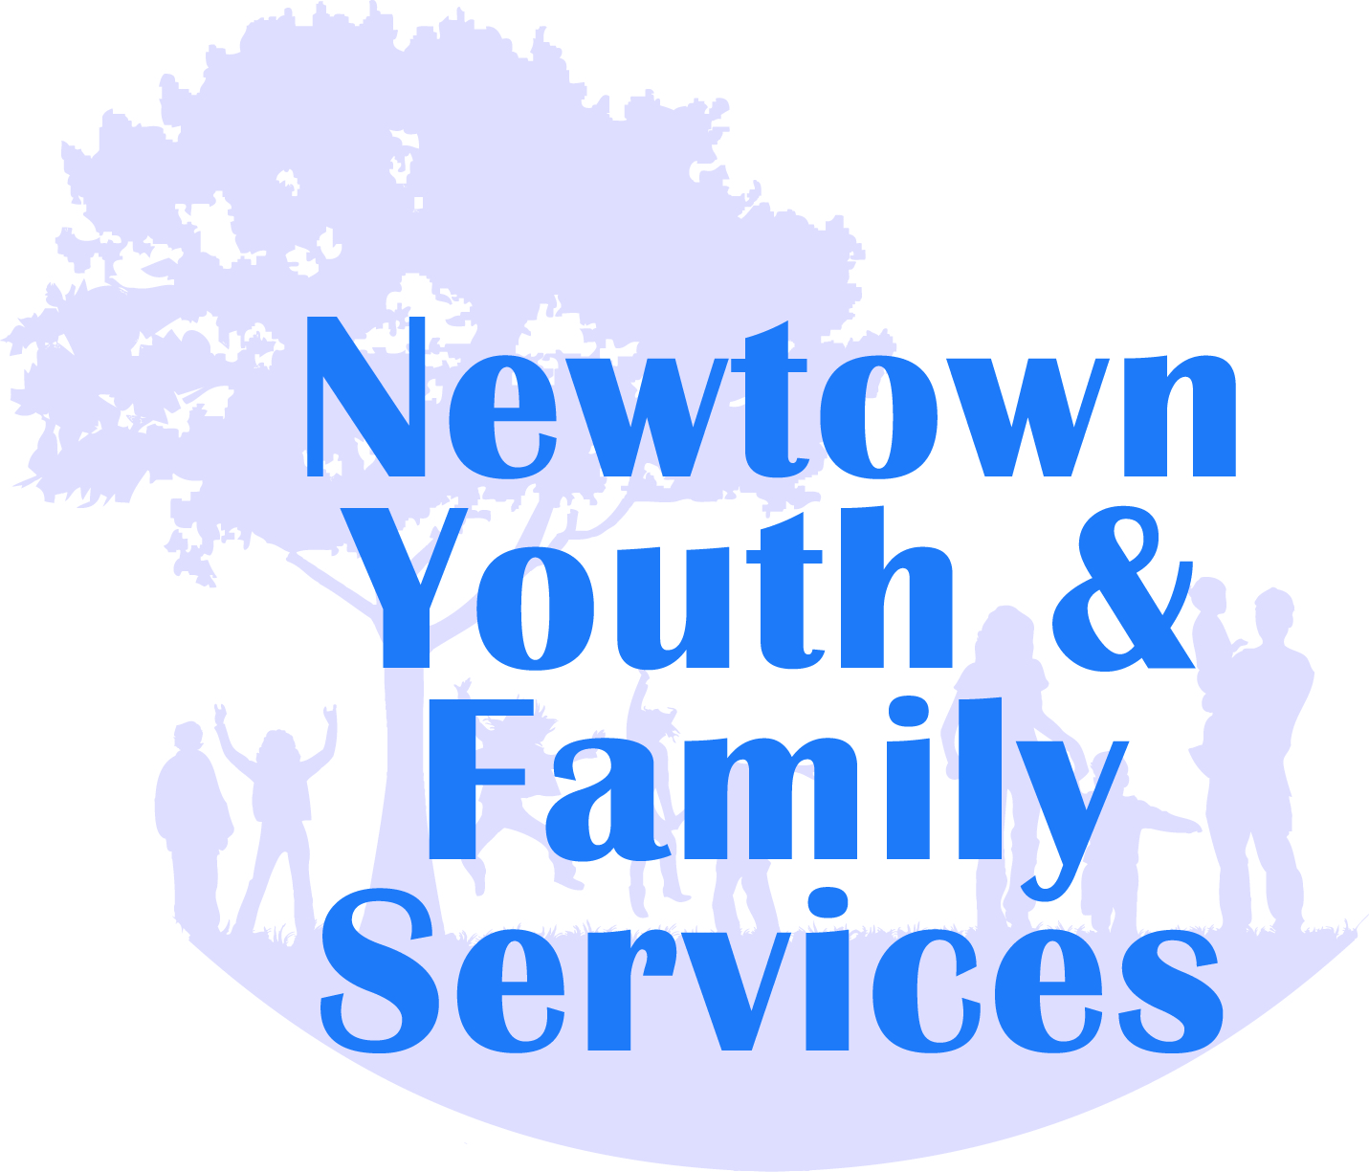
Dear Potential Mentor:
Mr. Tolson and Ms. Preneta from Newtown Youth and Family Services are looking for student mentors for FUSION 2018-2019! FUSION is a peer mentoring program, sponsored by a CSC Prevention grant through NYFS, which matches juniors and freshmen to help make the transition to NHS a great experience. Students work together throughout the year, enhancing relationships; positively shaping choices and attitudes; and just having fun! In addition to meeting weekly, FUSION has planned activities and field trips. STUDENTS MUST ATTEND MONDAY MEETINGS OR WILL NOT BE ABLE TO PARTICPATE IN FUSION. This is a full year program. If you are responsible, you make good choices, you have time available outside the school day and you would like to be considered for a mentor in Fusion for next school year, complete the form below and return it to Mr. Tolson via email at jefftolson@gmail.com, drop it off at NHS or fax it to NYFS.
Mentor Responsibilities:
- Attend Advisory daily with your FUSION partner.
- Attend mandatory Mentor training
- Familiarize your mentee with school culture, encourage involvement in extra curricular activities
- Must volunteer minimum of (2) shifts at a Newtown Youth & Family Services community related event
If responsibilities are not fulfilled, opportunity being a Mentor will be revoked immediately.
By signing here, I understand the responsibilities/eligibility of being a Mentor for the FUSION program and if I do not fulfill the responsibilities, I too understand that I will no longer be a Mentor for the FUSION program. I understand that I will be randomly surveyed, my responses will remain anonymous, and however, the information from all surveying will be combined together with other FUSION students and reported to members who are working on implementation of the CSC Prevention Grant.
_____________________________________________________ ___________________ Mentor Signature Date
By signing here, I understand the responsibilities/eligibility of my child being a Mentor for the FUSION program and if my child does not fulfill the responsibilities, I too understand that they will no longer be a Mentor for the FUSION program. I understand that my child will be randomly surveyed, their responses will remain anonymous, and however, the information from all surveying will be combined together with other FUSION students and reported to members who are working on implementation of the CSC Prevention Grant.
□ I give the FUSION Program permission to photograph my child. The photographs may be used in any of the media used by Newtown Youth and Family Services, Inc for promotion including website, newsletters, social media, leaflets, posters.
Parent/ Guardian Name(s): _________________________________________________
Parent/Guardian Signature Date
_______________________________ ________________________

Mentor Application
Part I:
Name: ______________________________ Age: ____ Cell: ____________________
Email (THIS IS IMPORTANT! This is how we will stay in touch with you) _________________________________
Part II: Respond in the spaces provided only
Why do you want to become a Mentor?

What, in your opinion, is the most important advice you can give to a 9th grade student?

What are you looking for in a mentee?

What clubs/sports/activities are you involved in and out of school?
Fall:
Winter:
Spring:
What are your interests (what do you do in your spare time) not mentioned in the question above?
What are your strengths?

What are your weaknesses?

List ideas of how you can reach out to your partner during the first month of school?

What are some things you can do that are fun and will also serve the community?

